Game Design Document
Pixel Guild Games (PGG) // 2026

Working Title
TecMon

Concept Statement
This is an iTec themed creature collector which will grow over time with contributions from students in the iTec Program. Each year, the secondary 1 students will design their own creatures, and the secondary 5 students will collaboratively design a region, so the game can continue to expand and be influenced by each cohort.

Genre(s) :
Creature-Collector, Turn-based RPG, Strategy & Puzzles

Unique Selling Points
The game will grow each year, with new creatures & regions. The game will also contain references to the iTec program, its staff, and every student.

Visual and Audio Style
The game will be 2D with 16x16 tiles and an emphasis on gameboy-era synth music. There will be modern elements for lighting to make the game feel fresh. While inspired by Pokemon, the game will have a visually distinct art style which is a hodge-podge of the various styles of each student who contributes.

Game World Fiction
The iTec program has had a major breakthrough in harnessing the power of a rare artifact found buried beneath the school’s learning commons. The artifact has caused our world to merge with another named “Tecna” after the program that discovered it. This merge has released an untold number of powerful creatures called TecMon into the world. Each year, new iTec students are tasked with adventuring out into the world to discover and document every TecMon they find. As they explore, they’ll discover regions from Tecna and uncover the true secrets of the iTec program. To ensure they are up for the task, they’ll have to overcome various obstacles,catch and train their TecMon in battle, and defeat powerful opponents to prove their readiness to explore.

Platform, Technology, and Scope
The game will be built on Godot, with creature design tools made in Python or JavaScript. The base game will have approximately 80 TecMon, and 1 full region similar in scope to the kanto region in Pokemon Red & Blue. Since this is a long-term project, more TecMon and regions will be added in the years to come.

Core Loops
Explore -> Find TecMon -> Catch TecMon -> Train & Level up TecMon -> Battle against other iTec Trainers -> Battle the town’s iTec Specialist & receive a passing grade -> Explore more -> Uncover Secrets

Objectives and Progression

The primary objective of the player will be mainly up to them, however several objectives will be focused on from a gameplay standpoint;
- Catch every TecMon
- Explore the entire region
- Pass every assignment
- Build a powerful team
- Uncover the narrative
- Become a legendary TecMon Trainer

The game will increase in difficulty as you progress through the world, so increasing TecMon levels & stats will be pivotal in succeeding in later stages. Team composition will be equally as important.

The Tecmon evolution tree is as follows. Every TecMon will have 2 base forms and 4 special forms. The guardian form will act as a tank, power form is DPS, assist form is heals & status effects. The respective forms will have their own stat changes, movesets, and appearances. The bond form is a special form that you can only get by keeping your Tecmon at the 2nd evolution stage until a maximum bond is acquired, unlocking this all-rounder form.
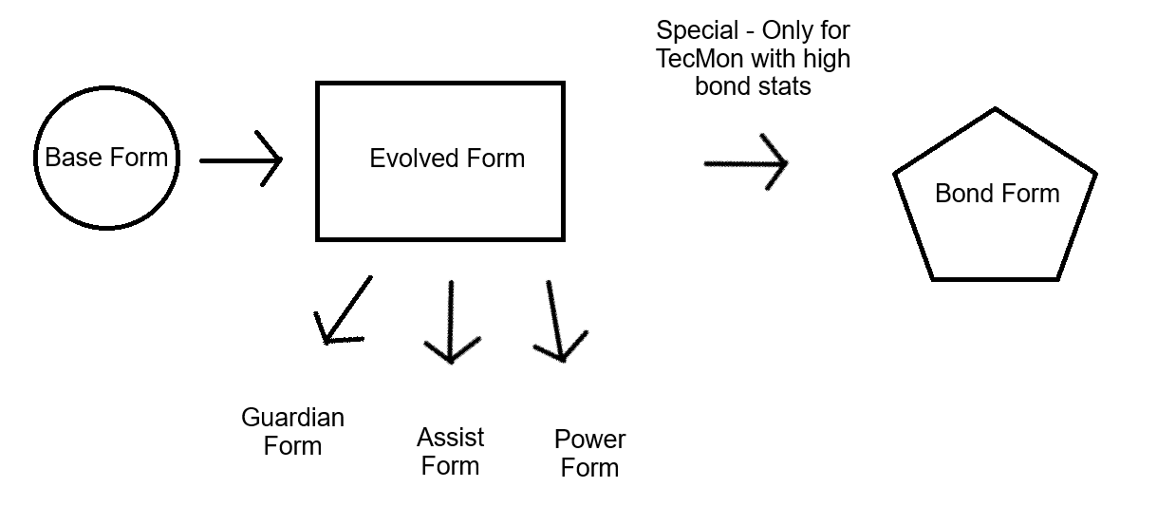

As each region is added, the level cap will increase and new types and weaknesses will be added, so players will have new challenges to overcome with each generation.

Interactivity
The player will be able to unlock skills over time that open up pathways to explore the region more thoroughly. There will be various types of terrain to cross, and the player will interact with the game world through a 3rd person sprite in a tile-based region. Control options will include Keyboard & Mouse, or Controller.

